SERMON NOTES

Small Group Devotions
Week of February 19, 2017
Jonah
“When God’s Grace is Too Much”
Jonah 4
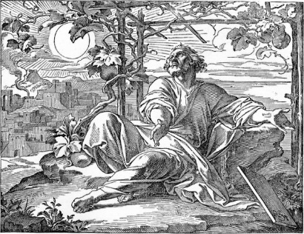

“And Jonah stalked to his shaded seat and waited for God to come around to his way of thinking. And God is still waiting for a host of Jonahs to come around to His way of loving.” Coming Around

In what ways do we often wait for God to come around to our way of thinking?

What do you think “God’s way of loving” means? How is that different than our way of loving?

Undeserved Grace

Supplemental Text: Luke 15:11-24

In Jonah and in the Parable of the Prodigal Son, we learn a lot about God, grace, and those undeserving. What connections can you make between the first three chapters of Jonah and the first portion of the parable in regards to those three things? How do these stories help you understand God, grace, and yourself?

Grace is only ever too much for others if we forget that we are as undeserving of that grace as they are. Can you count the ways that God has showered grace on you when you didn’t deserve it? On a personal note, who is your Nineveh and why would you think they don’t deserve God’s grace?

Unfair Grace

Supplemental Text: Luke 15:25-32

Jonah and the older brother become angry when they see God lavish His grace on those who do not deserve it, a grace that seems so unfair. How are the responses of Jonah and the older brother similar and different? How does God respond to each of them? What do these stories say about God and about us?

The reader is Jonah and Jonah is the reader. If you would insert yourself and your Nineveh into those final two verses (as well as the entire book), how would you respond to God’s last question? That’s a question that needs answered and you’re the only one who can.

