Making it Real

This week we learned that the hardest part of the Christian life is not right theology or discipleship, but being honest with ourselves and whether we’re practicing what we preach. How do you think you could better practice what you preach this week? Use the questions below if you’d like, or share something unique.

How can you come alongside a brother or sister in Christ to lift their burdens and help them journey along the Holy life?

What’s a way that you could begin serving without being noticed?

How might you exalt a co-worker, family member, friend, or church member instead of yourself?

Something else?

As you go about the rest of your week, take note of the temptations that come your way that would cause you to live differently than you speak. Keep a temptation journal; write down the details so that you can name it and better fight it in the future. And if you fail, write that down too. In your own time, share that with someone you trust so that you can find the encouragement to resist the temptation to serve yourself and better love God and your neighbor.
Verse of the Week: 1 John 3:18

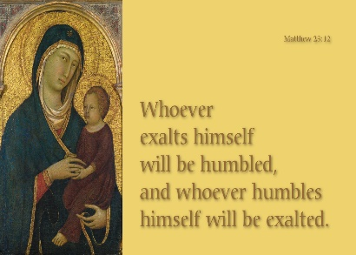
Small Group Devotions
Week of November 5, 2017
Do as I say, not as I do.
Matthew 23:1-12

Sermon Notes
Do as I say

They…

The Problem of the Passage

Humility

My Story

Looking back at your notes from this week’s teaching, was there anything you heard for the first time or that caught your attention, challenged, or confused you?

How do you relate to the saying, “Do as I say, not as I do?” Have you been on the receiving end of that? Have you been the one dishing it out? What were the reactions to that moment?

Why is it that you think we have such a hard time practicing what we preach?

Digging Deeper

Text: Micah 3:8-11
In reading through the various texts this week, what were the ways the Pharisees and Scribes in Matthew and the Prophets in Micah fell into temptation and stopped practicing what they preached? Why do you think that mattered?

In looking at your list above, is there a particular temptation that you feel more susceptible to than others? Why do you think that is?

Text: 1 Thessalonians 2:9-13
Contrast the behaviors of the religious leaders above with Paul and his fellow evangelists in 1 Thessalonians. How does Paul model for us the humility that Jesus speaks of in Matthew? How could we say that Paul, “practices what he preaches,” in this text? Why do you think this is important in the Christian life?

